Chapter 8, Problem 70.

For the circuit in Fig. 8.115, use Pspice to obtain v(t) for 0 < t < 4 s. Assume that the capacitor voltage and inductor current at t = 0 are both zero.
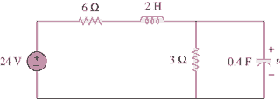

Figure 8.115
For Prob. 8.70.

